Chapter 1

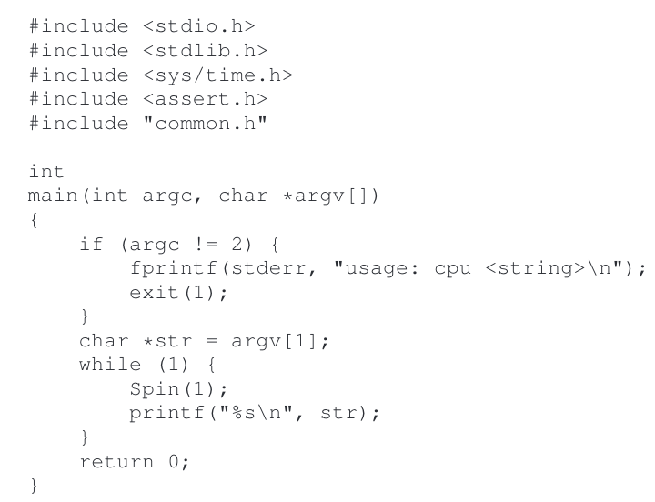

-input : A

-call spin , check the time for a second, print out string user input, repeat forever.

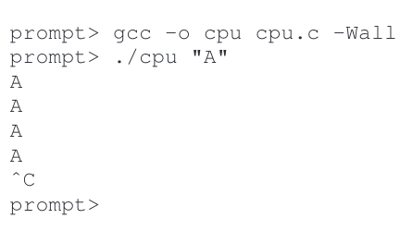

-^c : program run in foreground

-&: program run I background

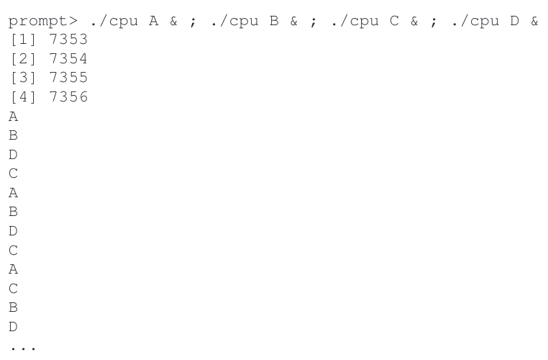

-we only have one processor , somehow four of these program seem to run at same time

- illusion many virtual CPU exist called virtualizing the CPU

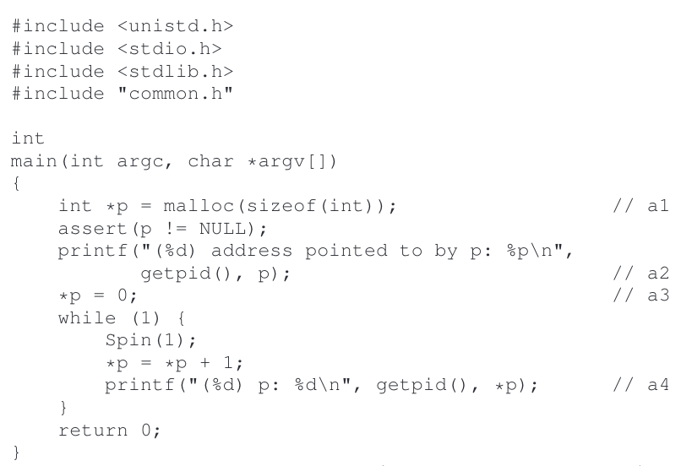

-a1: allocate some memory

-a2: print out the address of memory,

-a3: then put number zero onto first slot of newly allocated memory

-a4: loop, delay for second, increment the value stored at the address held in p.

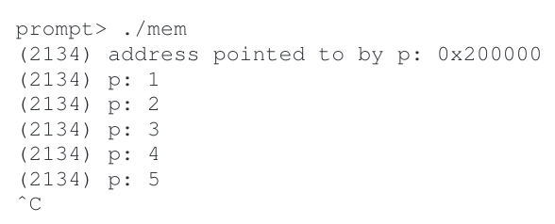

-with every print statement, it also prints out the process identifier the Pid

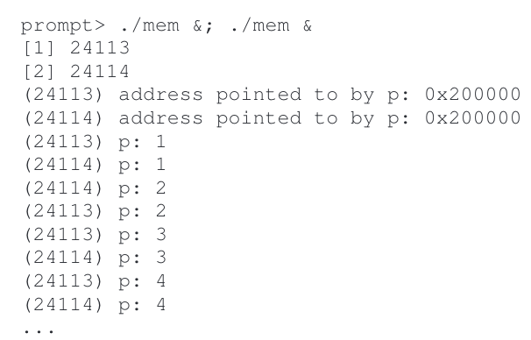

-each running program has allocated memory at same address (0x20000)

-yet, each seem to be update value at 0x200000 independently

-here OS is virtualizing memory

Multi-thread program

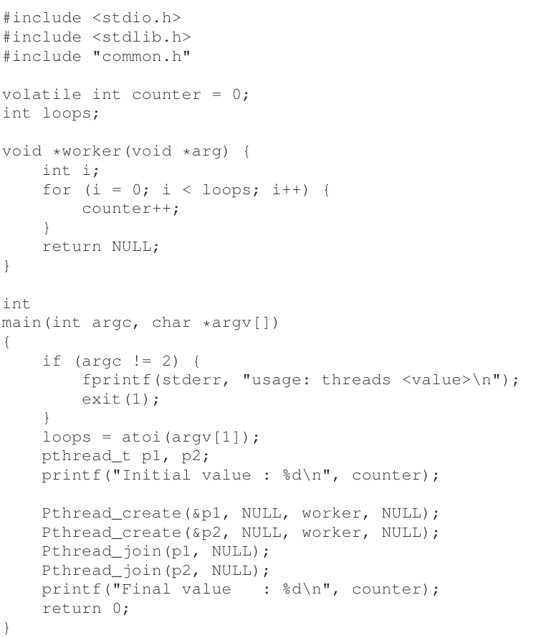

-main program create two thread using Pthread_create()

-thread as function running within the same memory space as other function

-each thread start run in routine called worker() , which increment counter in loop

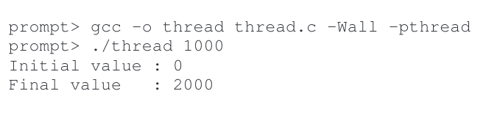

-input value: set loop to 1000

-when two thread are finished , each thread increment the counter 1000 , final 2000

-set loop to N , final output 2N

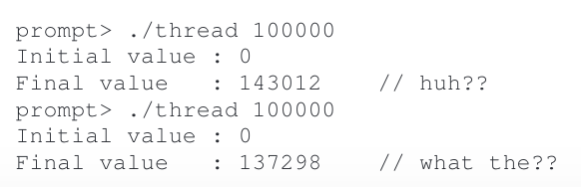

-run same program with higher value for loop

-counter increment and take 3 instruction: one load value of counter from memory into register

-one increment it, one store it back into memory. Because these 3 do not execute atomically, strange thing can happen. Problem of concurrency

-



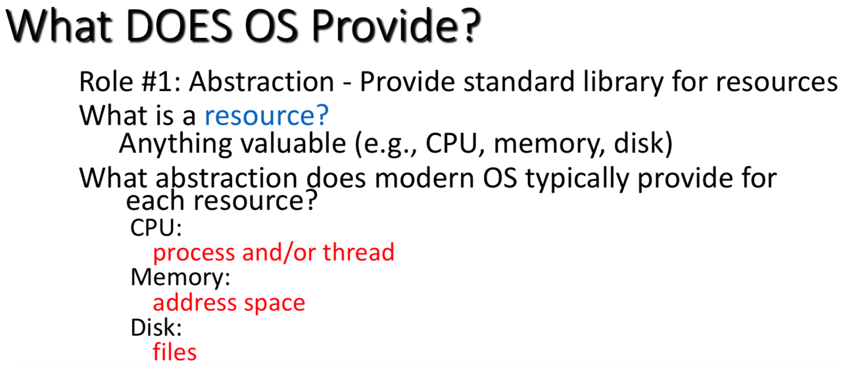



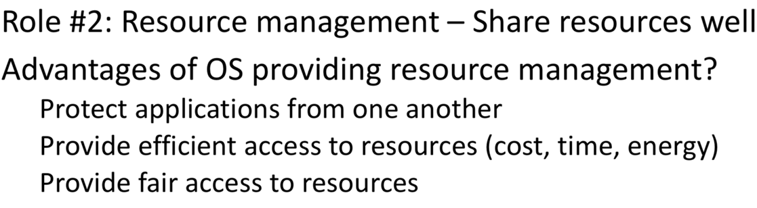

**what is difference between process and program**

program is static instruction that developed to control the CPU

process is an executing program

**what is PID**

-process Identifier, unique number to specify the one process from another

There are **two components** of the PCB, the state of the CPU and the state of resources associated with the process.

Where is the state of a process stored when the process is not executing ?

-Process control block

CPU itself has following three components.

* Memory or Storage Unit
* Control Unit
* ALU(Arithmetic Logic Unit)

**What is difference between real memory cell and address space in program**

**-**memory cell is address that CPU used to manipulate cell, cell are named sequentially started at location 0 to 2n -1

-address space is a range of valid address in memory that are available for program to access

**Virtual memory** is stored on the hard drive and is used when the RAM is filled.

**Physical memory** is limited to the size of the RAM chips installed in the computer.

**OS**

-central software that manages and allocates computer resources

**KERNEL**

**-**Access kernel through an API

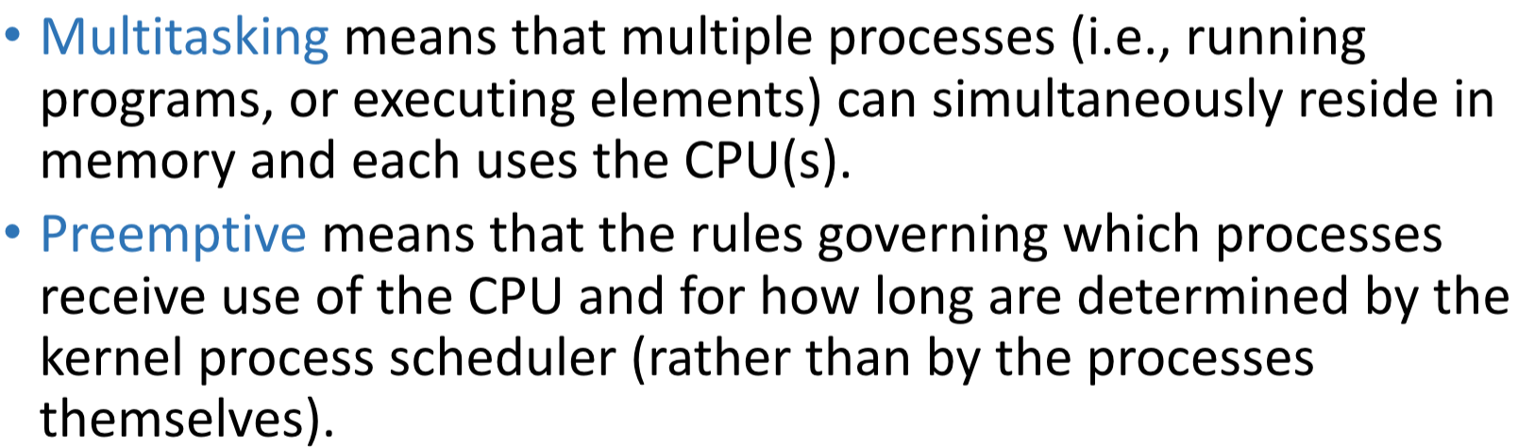**Modern OSs** are preemptive multitasking operating systems

**a kernel** component to switch the virtual computer onto a real CPU in order to execute the code of the virtual computer

**Memory management**

**memory address space:**

-physical memory: actual address space or set of real address in main memory of Cpu

-virtual memory: address space of process

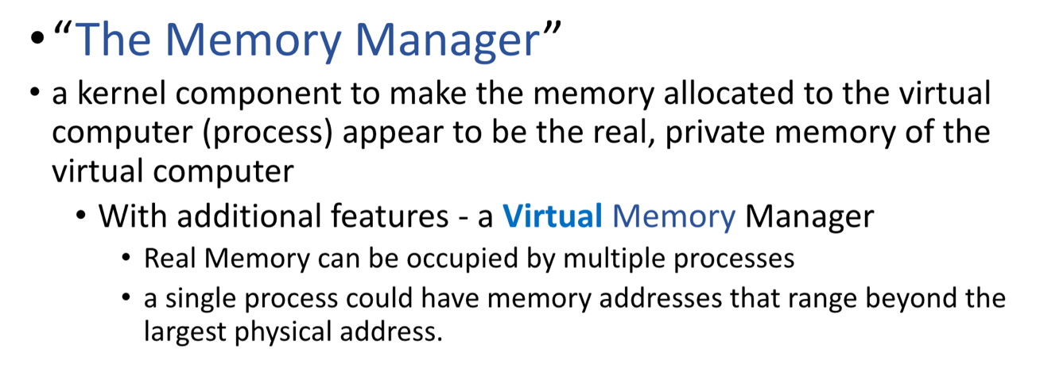

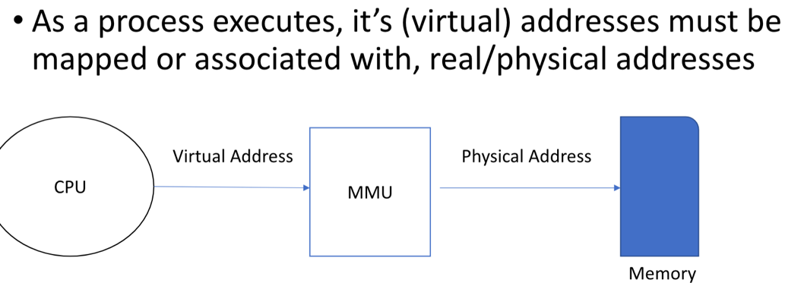

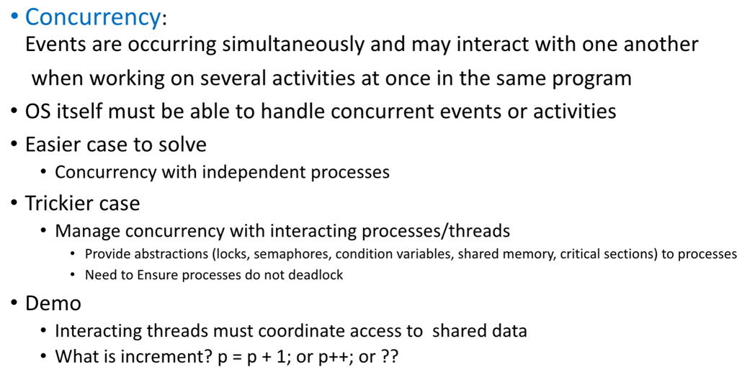

thread shared:

global variable , heap, static data

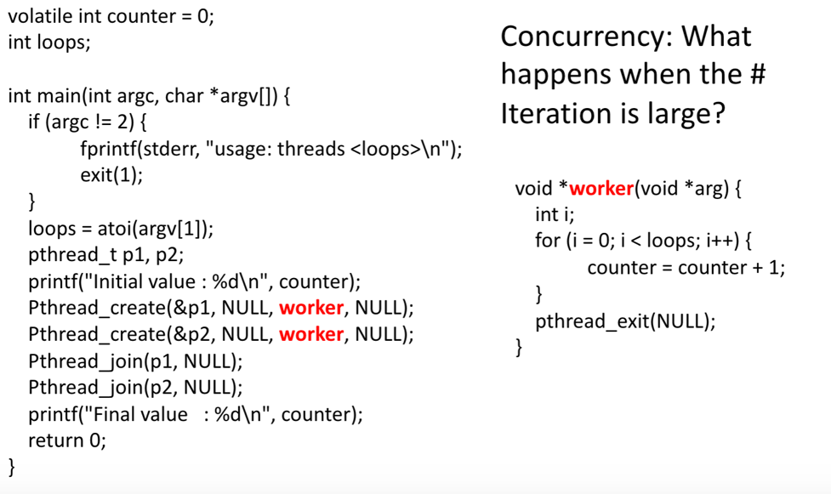

-concurrent thread

-value of p2 is over written p1 , result of strange value

-atomic operation: program operations that run completely independently of any other processes.

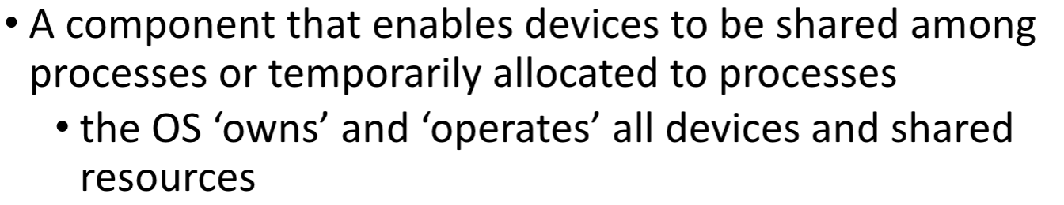

**Persistence**: Provide permanent access to information

-Lifetime of information is longer than lifetime of any one process

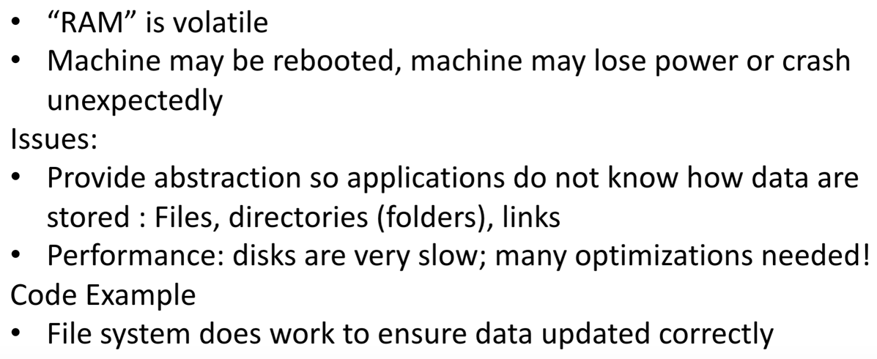

Is RAM Persistence storage:

-not, data is erased when power is turned off

what is persistence storage

-any data **storage** device that retains data after power to that device is shut off.

Is ROM Persistence storage

-yes, typically used for the task of secondary **storage**, or long-term **persistent storage**. non-volatile

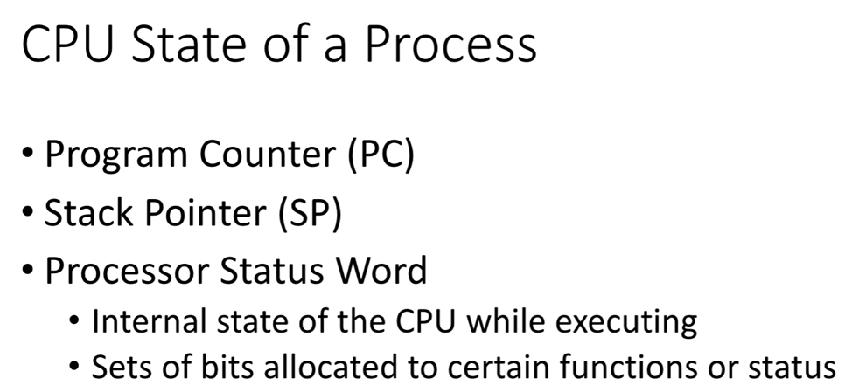

**Event**

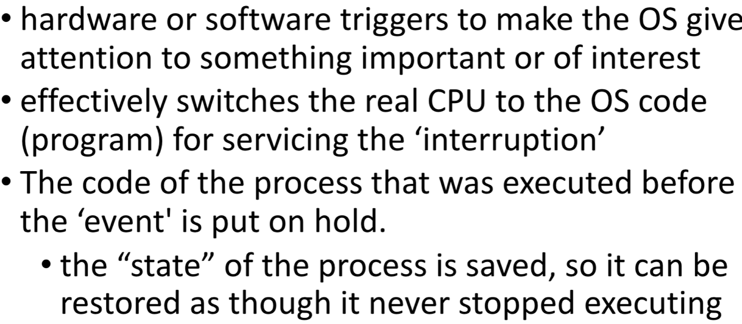-interrupt:

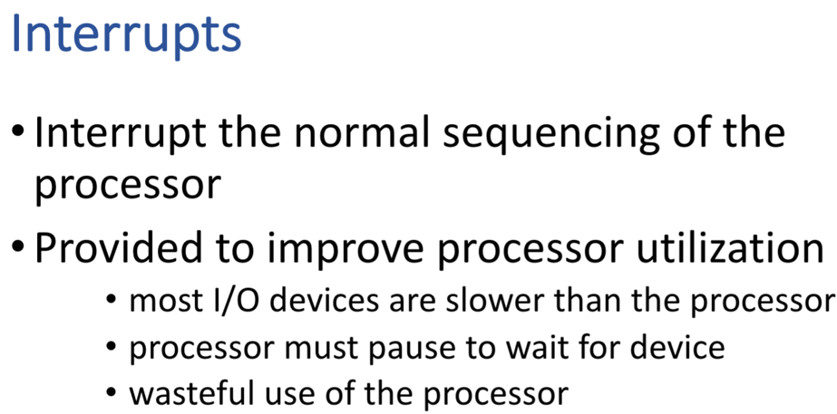

**Classes of Interrupts**

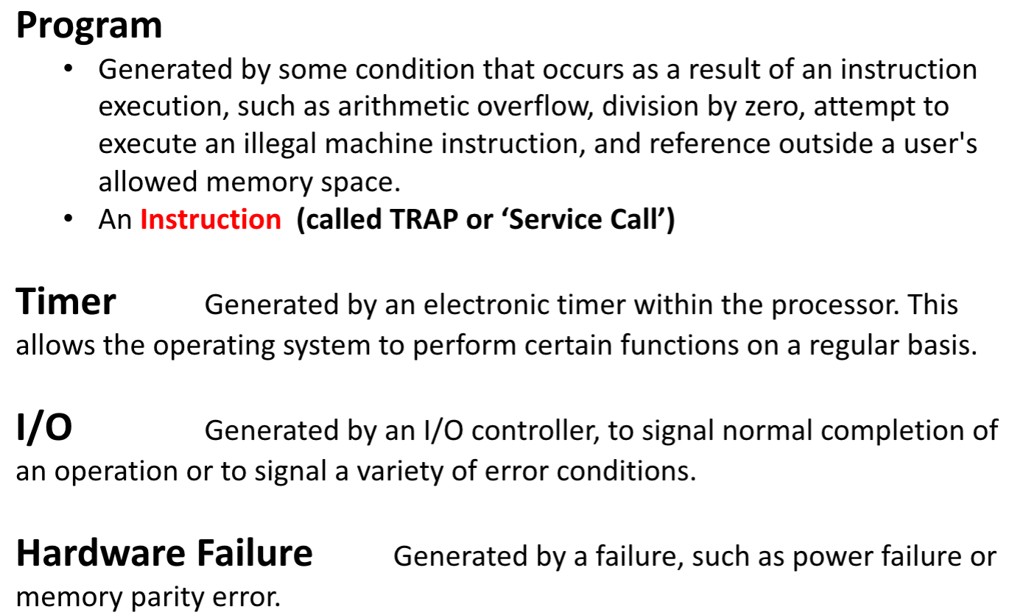

**Synchronous vs Asynchronous Interrupts**

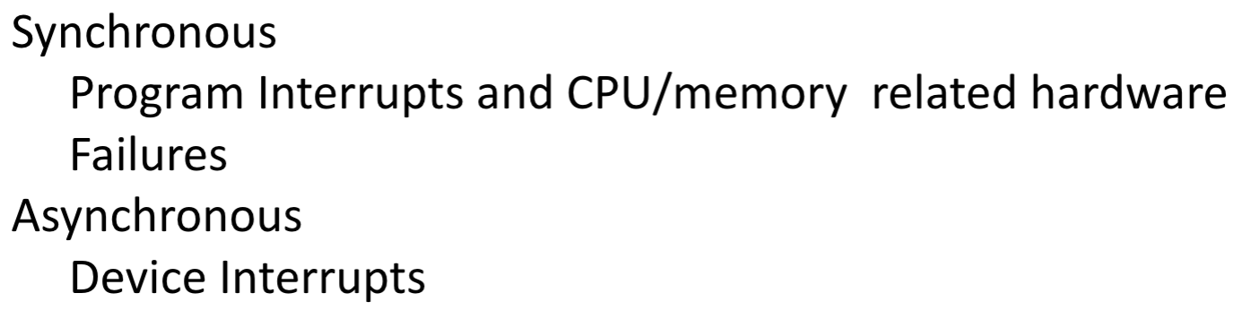

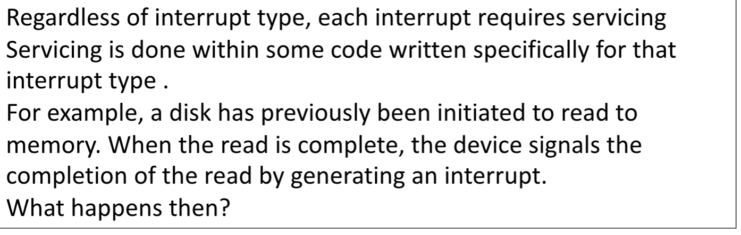

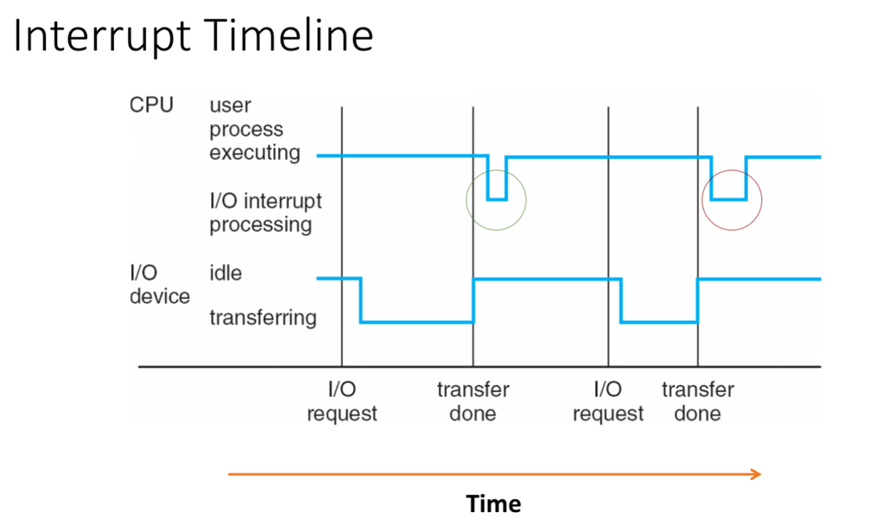

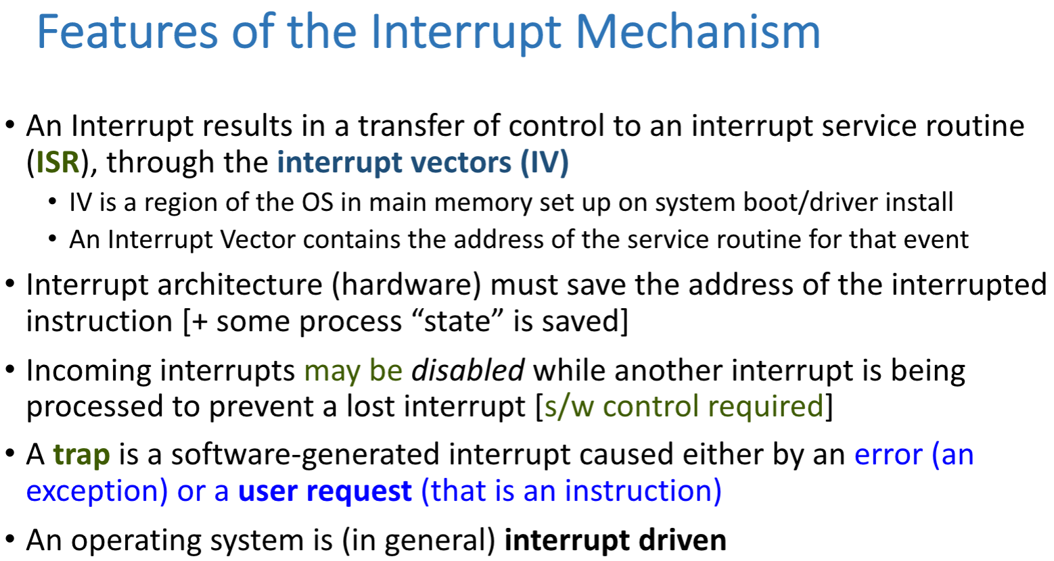

Time Savings Due to the Use of Interrupts,

rather than I/O Wait

Interrupts; short I/O wait

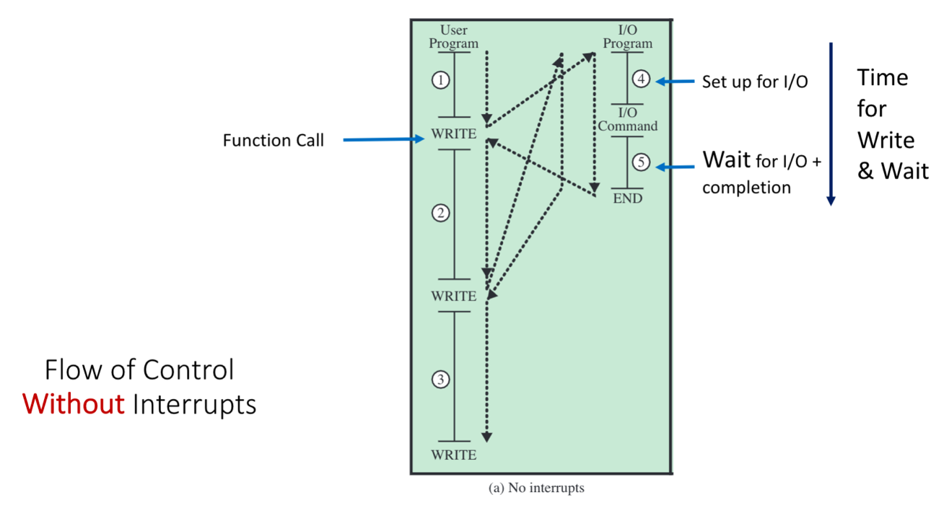

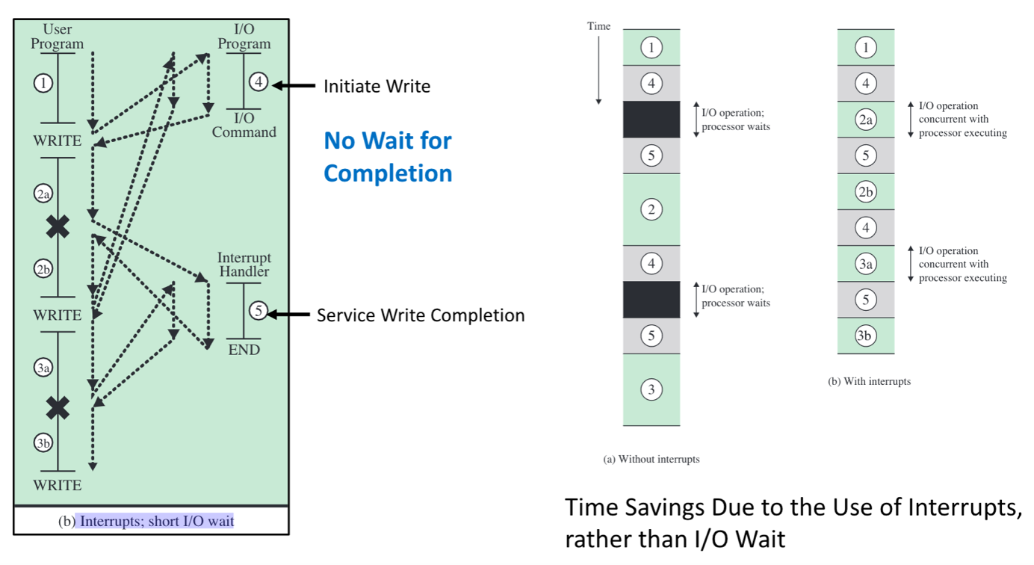

what is **interrupt**

- defined as an event that alters the sequence of instructions executed by a processor

What is meant by a **synchronous** interrupt

-produced by the CPU control unit while executing instructions

- and are called **synchronous** because the control unit issues them only after terminating the execution of an instruction,

-program interrupt, software interrupt

What is meant by a **asynchronous** interrupt

- generated by other hardware devices at arbitrary times with respect to the CPU clock signals.

-hardware interrupt, device interrupt

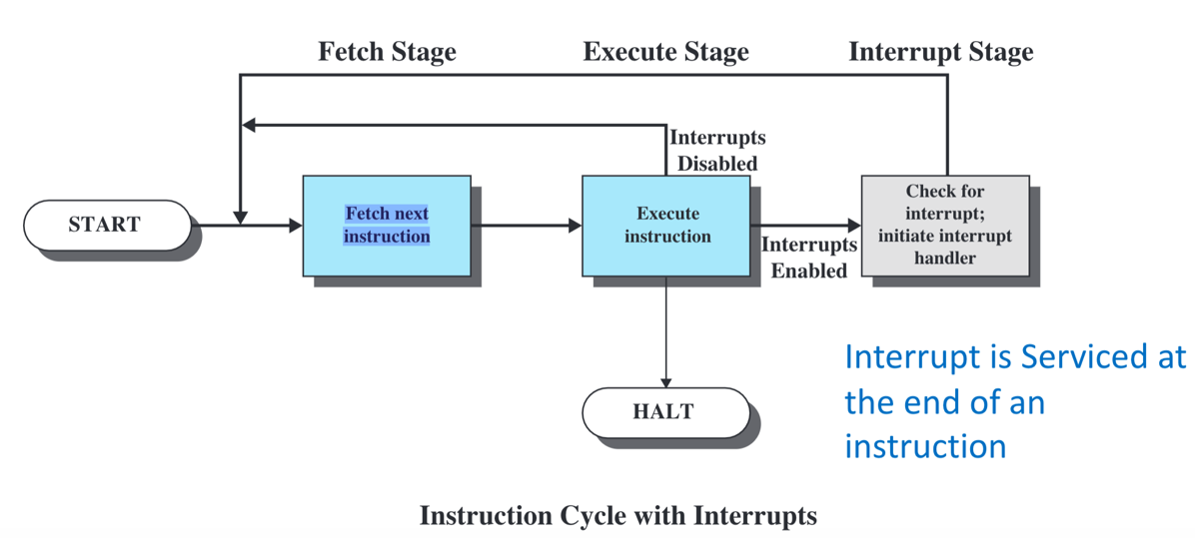

Interrupt feature

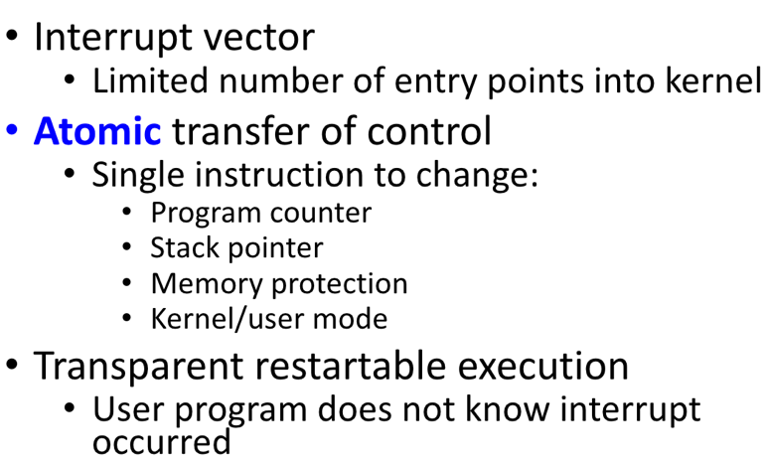

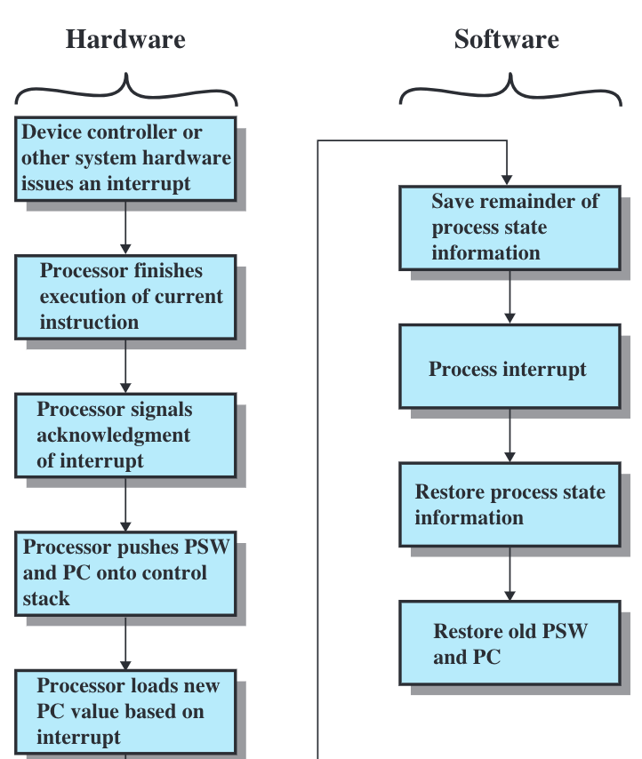

Multiple interrupt

-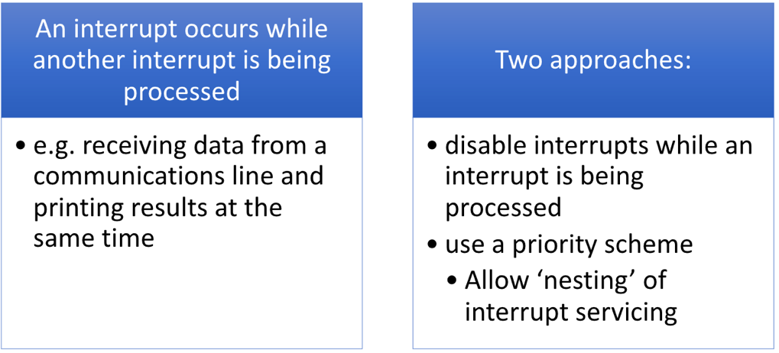

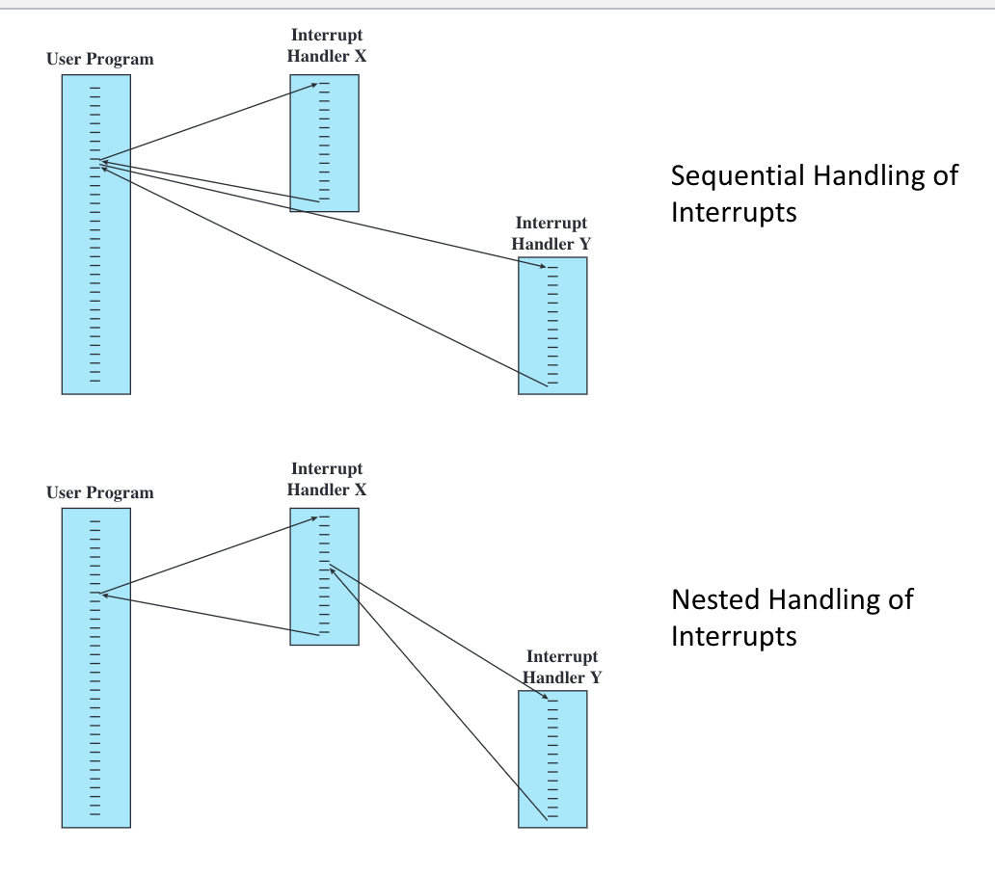

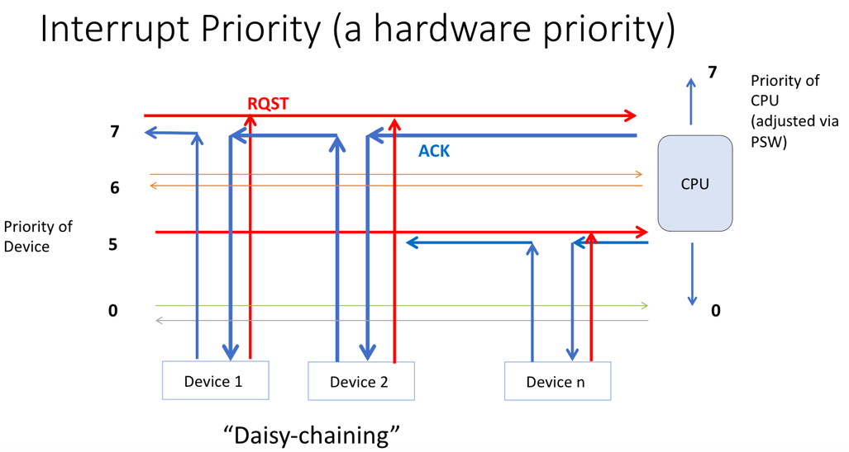

-The priority of the CPU is set by the kernel in the PSW.

-If an interrupt request arrives on a priority line that is **higher than the interrupt priority** of the CPU, the interrupt request will be granted; otherwise, the servicing of the interrupt is postponed until the priority of the CPU **drops lower than the priority** of the requested interrupt

what are the three principle register that specify the state of the CPU

-program counter, stack pointer, memory

Hardware Support: Dual -Mode Operation

-kernel: core code of the operating system that manages resources and

provides services to other parts of the OS

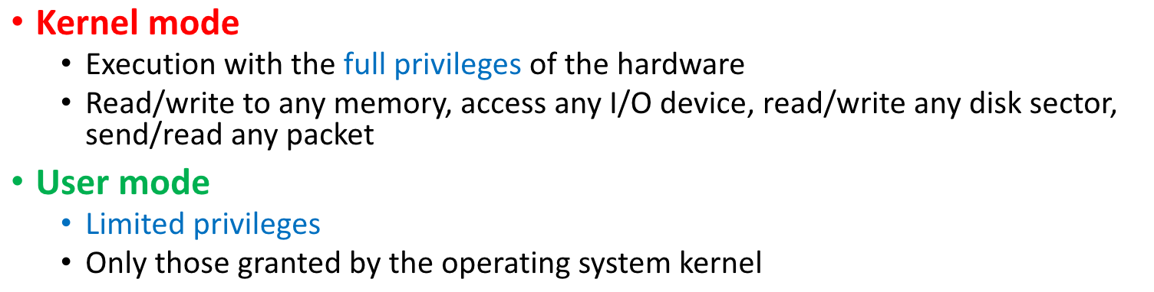

**Kernel mode** is when the CPU is executing with full privileges: execution of any instruction, addressing any cell in memory and direct access to all devices connected to the system. The kernel executes its code and components in kernel mode.

**'user mode'**, is with limited privileges, including a reduced instruction set, access to limited sets of addresses, and access to devices only through requests to the kernel. The control of the CPU operating mode is **through the PSW**

**The PSW** is a very important register as we have discussed. It is a privileged CPU register, accessible only to the kernel.

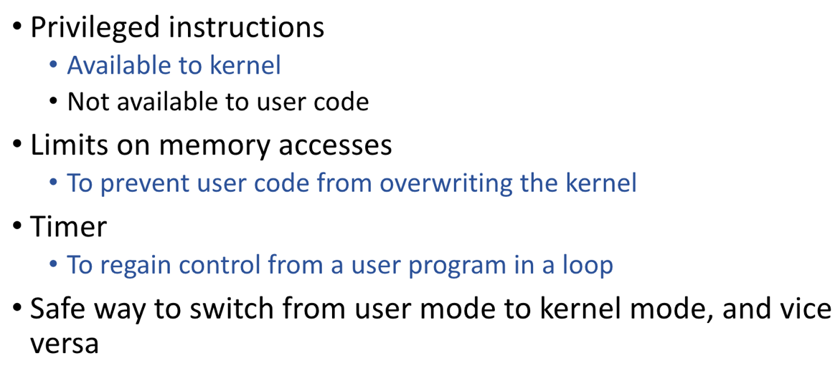

What should happen if a user program attempts to execute a privileged instruction

-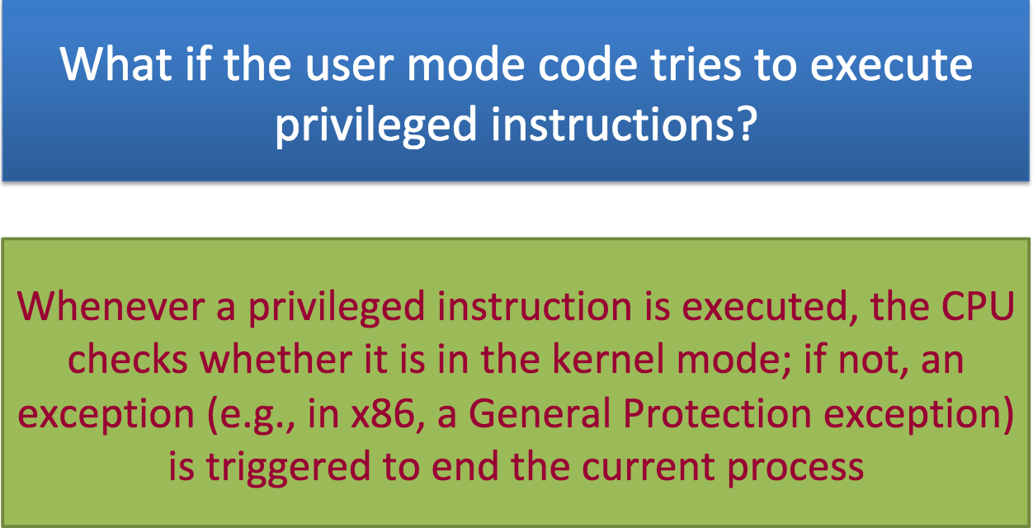

Mode set in Processor Status Word/Register

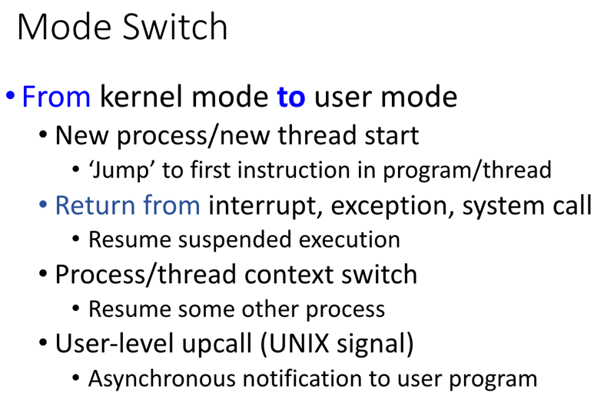

Memory related

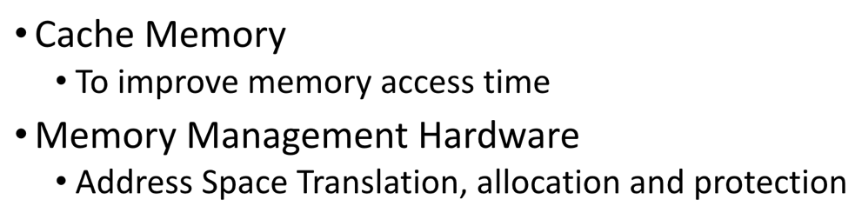

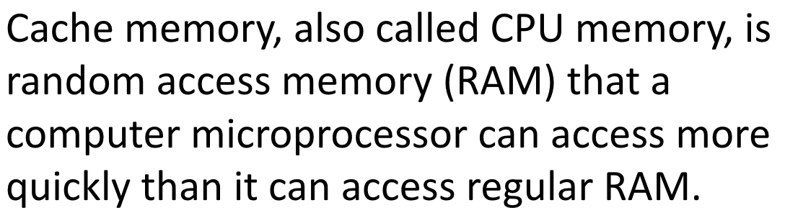

Memory Hierarchy

-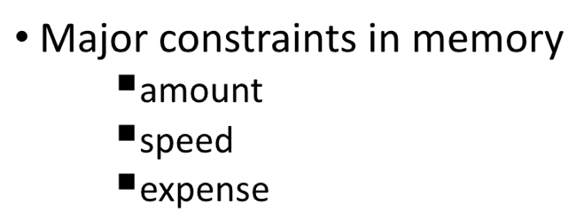

-amount: capacity

-speed: time

-expense: cost

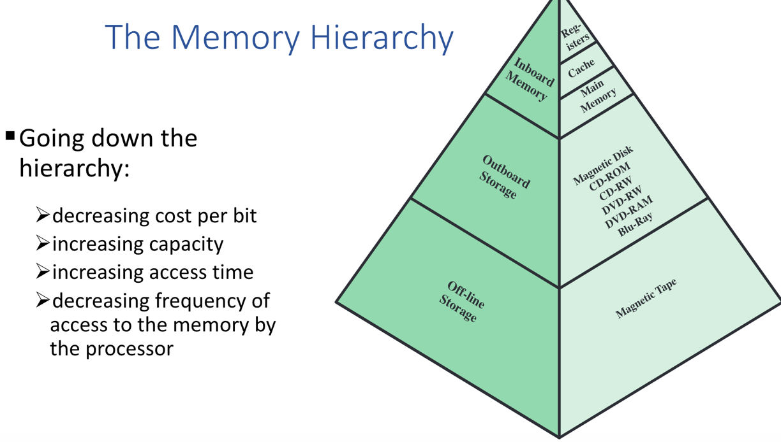

-The key to the success of this organization is the decreasing frequency of access at lower (slower) levels.

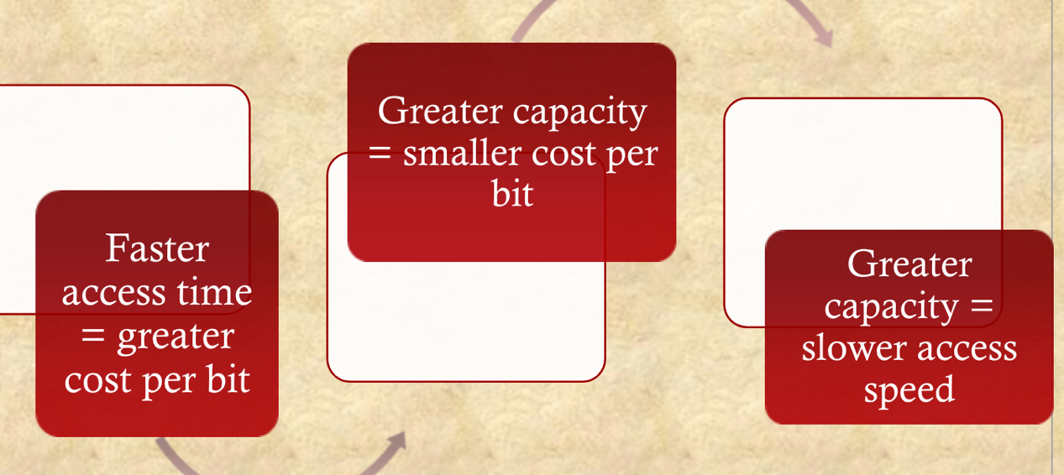

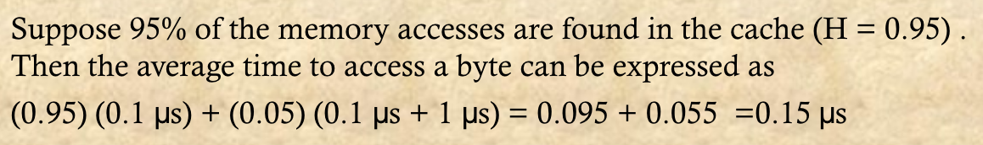

Review: interrupt

-If an interrupt occurs when a process is executing, the interrupt is serviced at the end of the instruction during which the interrupt arrived

- Since the ISR will be executing on the same CPU as the interrupted code, anything in the CPU belonging to the executing process is volatile and must be saved

- The immediate critical items are **the instruction pointer (IP or PC) and the PSW**.

- A call to an I/O function can initiate the I/O operation and rather than waiting for the I/O to complete, the function can return to the calling program

- Sometime in the future when the I/O completes, the device will generate an interrupt, notifying the OS that the I/O is complete and the kernel can notify the program. This parallelization (of CPU and device activity) makes a system more efficient, keeping the CPU always busy

- Interrupt servicing can be disabled. This can be done by the kernel. Interrupt requests that occur when interrupts are disabled are not necessarily lost

- The device raising the request while interrupts are disabled has its interrupt request left in **a 'pending' state.** Once interrupts are reenabled, the request will be honored, and the interrupt serviced

- If an interrupt is being serviced, with the CPU executing in the ISR, and an interrupt arrives from another source, that second interrupt can be serviced. The same mechanism of saving process state and starting an ISR will occur. This **'nesting' of interrupt** servicing can occur at many levels.

-**The switch from kernel mode to user mode** happens when a new process or thread is created and started [fork(), e.g., is a function call to the kernel to start a process; once created, the process is started when the kernel returns to the first instruction in main().] in user mode. Return from an ISR to an interrupted process involves a return from kernel mode to user mode.

-Entry to kernel mode from user mode occurs automatically as a result of **interrupt servicing**

-**traps**, which are instructions to execute kernel code.

-System bus: provide for communicate among processor, main memory, i/o modules

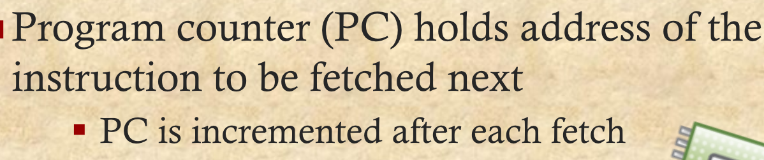



Process creation

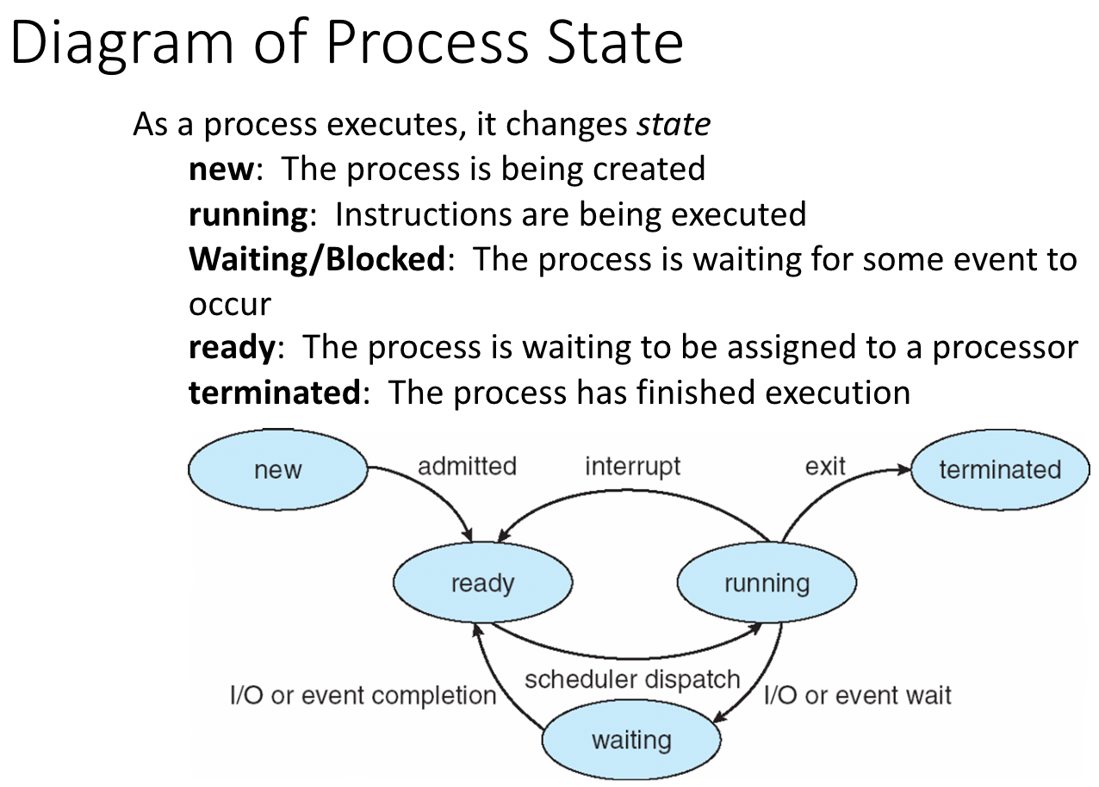

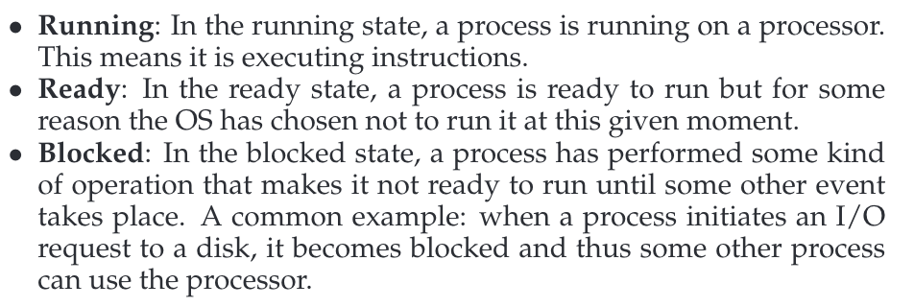

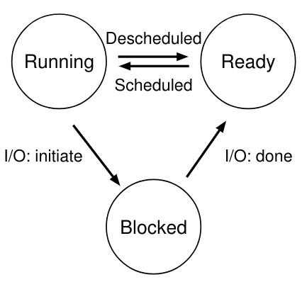

Two ways to create a process

•Build a new empty process from scratch

•Copy an existing process and change it appropriately

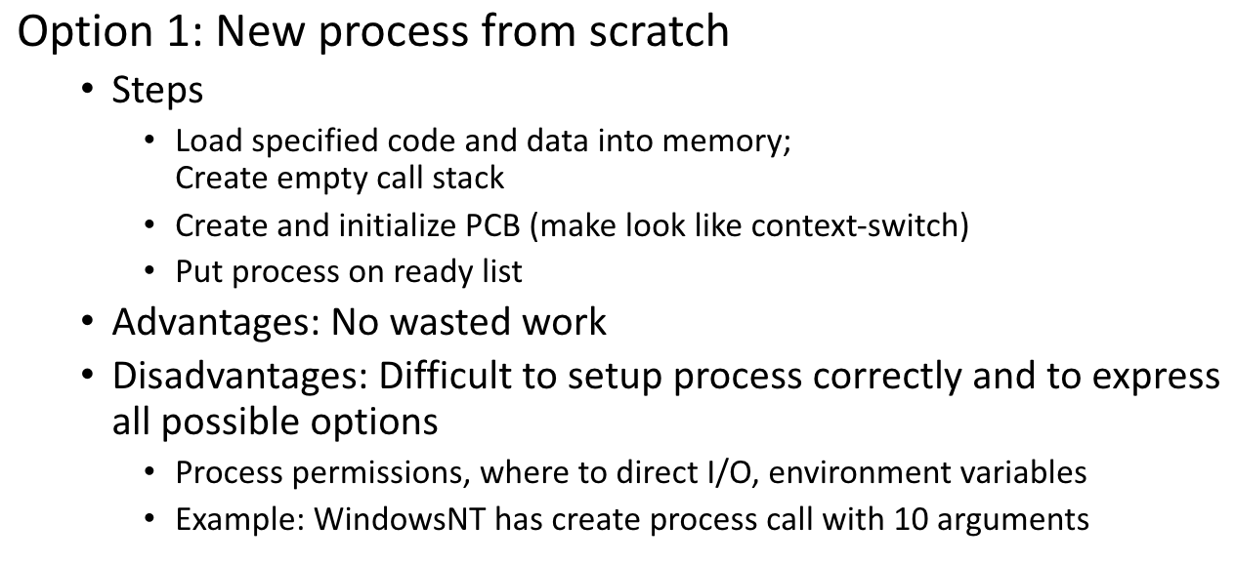

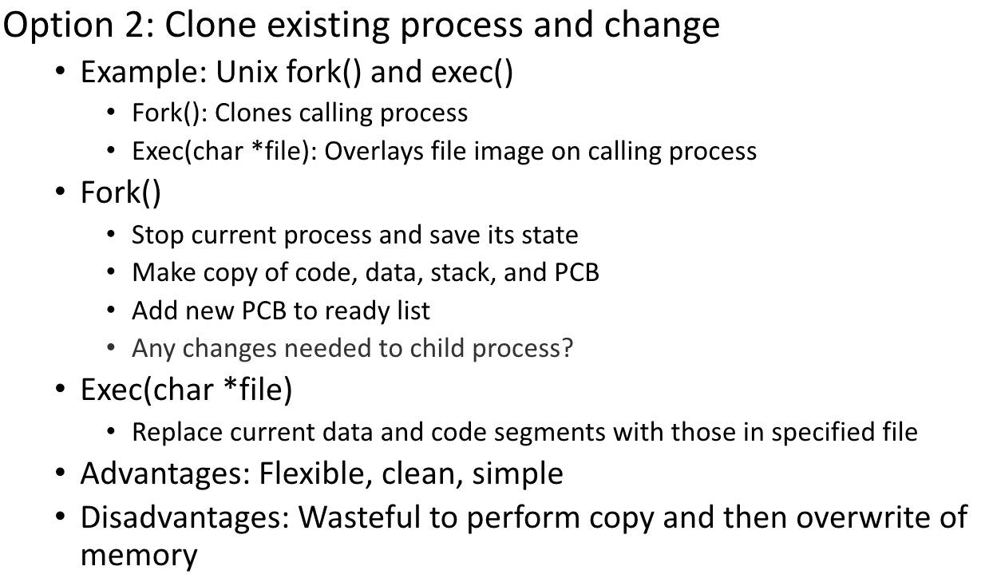

The Fork() System call

-Create a new process

•The newly -created process has its own copy of the

address space, registers, and PC.

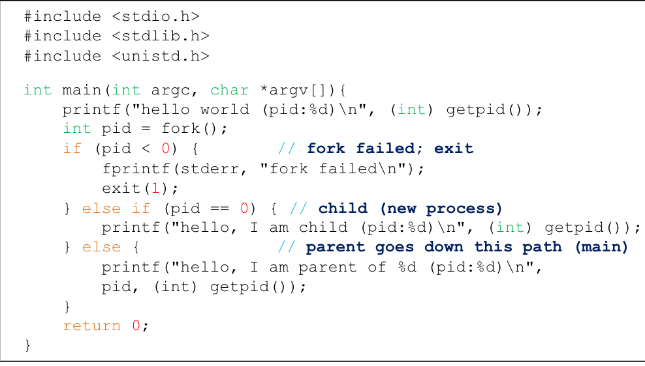

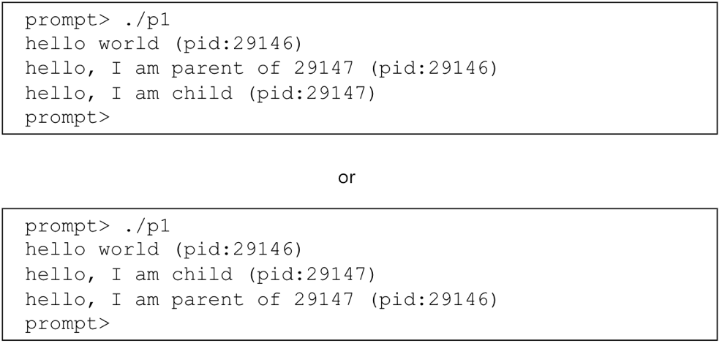

The wait() System Call

•This system call won’t return until the child has run and exited.

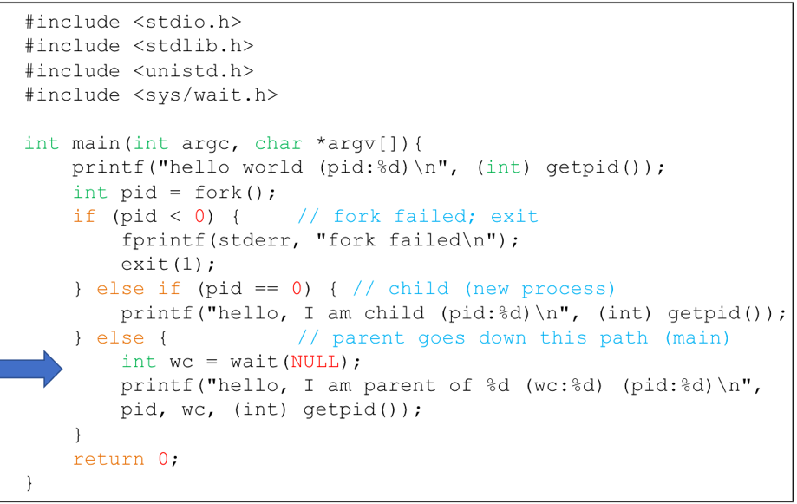

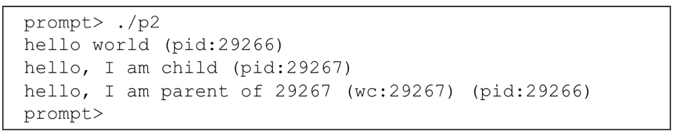

Process API

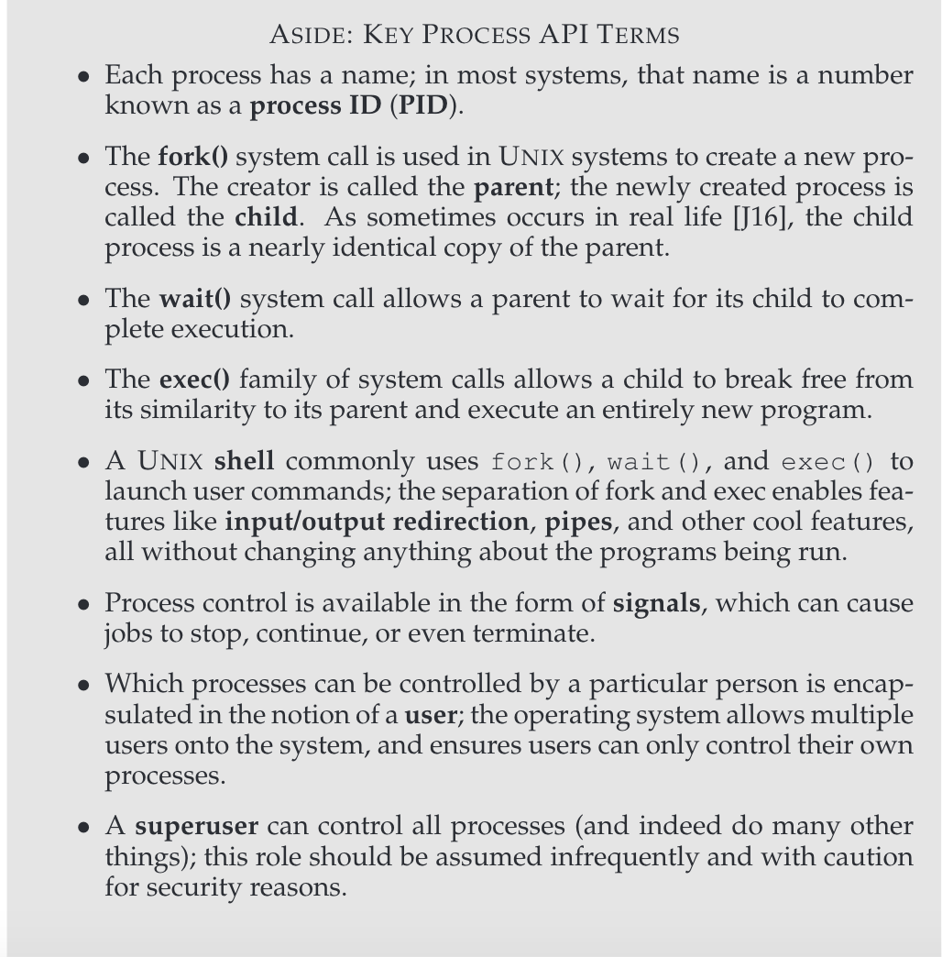

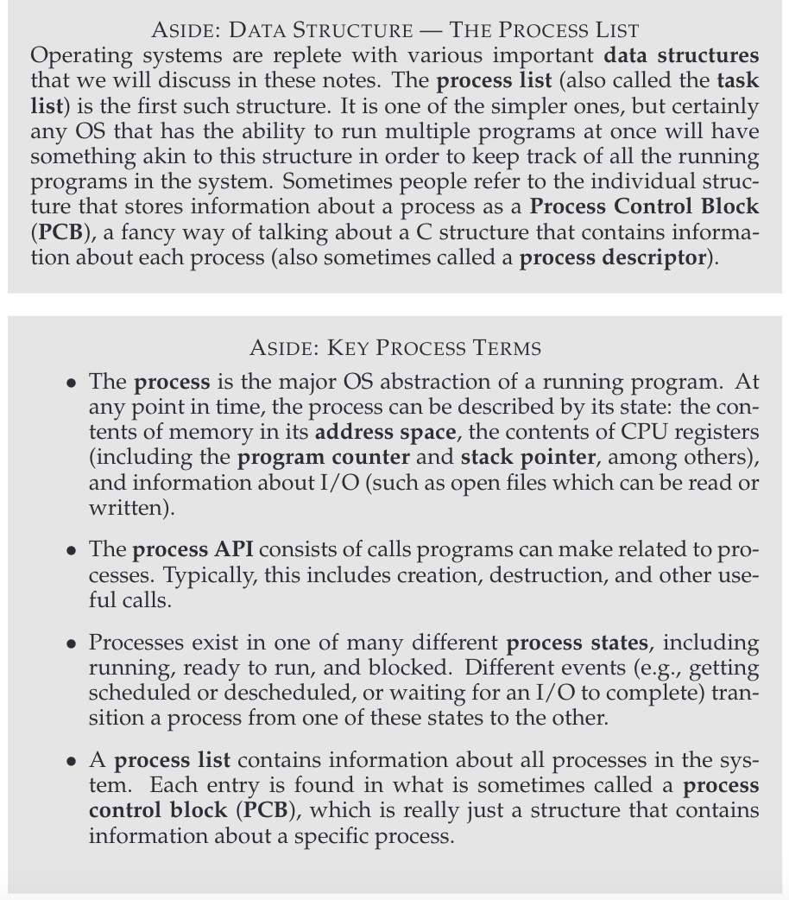

**Process creation**

-Load a program code into memory into the address space of the process

-The program’s run-time **stack** (local var., func. para. , return add.) is allocated

-The program’s heap is created

-The OS does some other initialization tasks (Input/Output(I/O) setup

-Start the program running at the entry point -namely, main()

**chapter 6:**

For example, when running in **user mode**, a process can’t issue I/O requests; doing so would result in the processor raising an exception;the OS would then likely kill the process.

**kernel mode**, which the operating system(or kernel) runs in. In this mode, code that runs can do what it likes, including privileged operations such as issuing I/O requests and executing all types of restricted instructions

**what should a user process do when it wishes to perform some kind of privileged operation**

**,such as reading from disk?**

-To enable this, virtually all modern hardware provides the ability for user programs to perform a

**system call**.

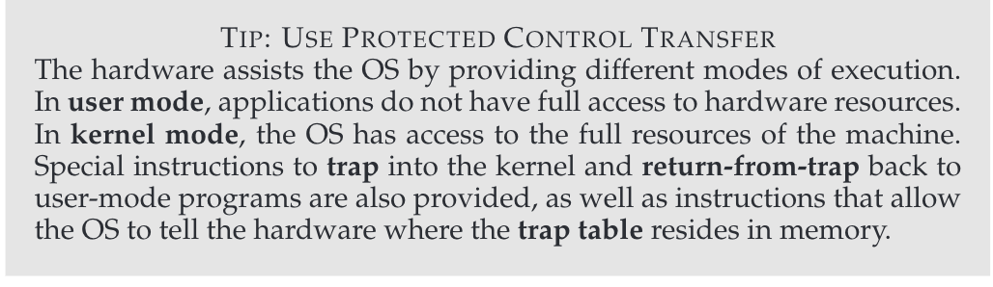

**Trap:**

-To execute **a system call**, a program must execute a special **trap** instruction.

-This instruction simultaneously jumps into the kernel and raises the privilege level to kernel mode;

-once in the kernel, the system can now perform whatever privileged operations are needed (if allowed), and thus do the required work for the calling process.

**Return from trap:**

When finished, the OS calls a special return-from-trap instruction, which, as you might expect, returns

into the calling user program while simultaneously reducing the privi-lege level back to user mode.

**Kernel Stack:**

the processor will push the program counter, flags,and a few other registers onto a per-process

kernel stack; the return-from-trap will pop these values off the stack and resume execution of the user-mode program

**Trap table:**

how does the trap know which code to run inside the OS?

-Clearly, the calling process can’t specify an address to jump to, doing so would allow programs to jump anywhere into the kernel

-The kernel does so by setting up a trap table at boot time. tell the hardware what code to run when certain exceptional events occur : hard-disk interrupt takes place, when a keyboard interrupt occurs,or when a program makes a system call

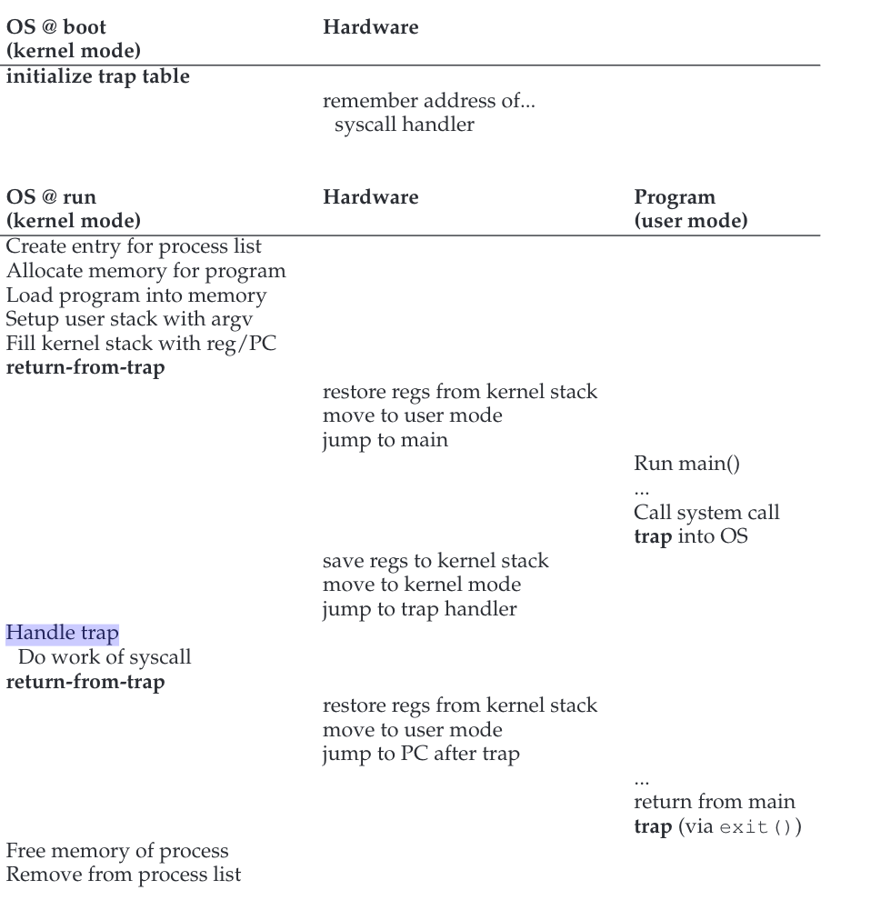

Switching Between Processes

-the OS should just decide to stop one process and start another

How can the operating system regain control of the CPU so that it can switch between processes

-A Cooperative Approach: Wait For System Calls

-A Non-Cooperative Approach: The OS Takes Control

How to regain control without cooperative :

-a timer interrupt: is raised the interrupt, the currently running process is halted, and a pre-configured interrupt handler in the OS runs. At this point, the OS has regained control of the CPU

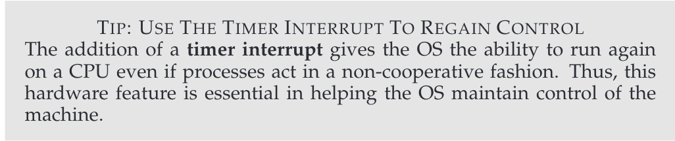

**Scheduler:**

-whether to continue running the currently-running process, or switch to a different one

**Context Switch:**

-If the decision is made to switch, the OS then executes a low-level piece of code which we refer to as a

context switch

-all the OS has to do is save a few register values for the currently-executing process (onto its kernel stack, for example) and restore a few for the soon-to-be-executing process

To save the context of the currently-running process, the OS will execute some low-level assembly code to save the general purpose regis

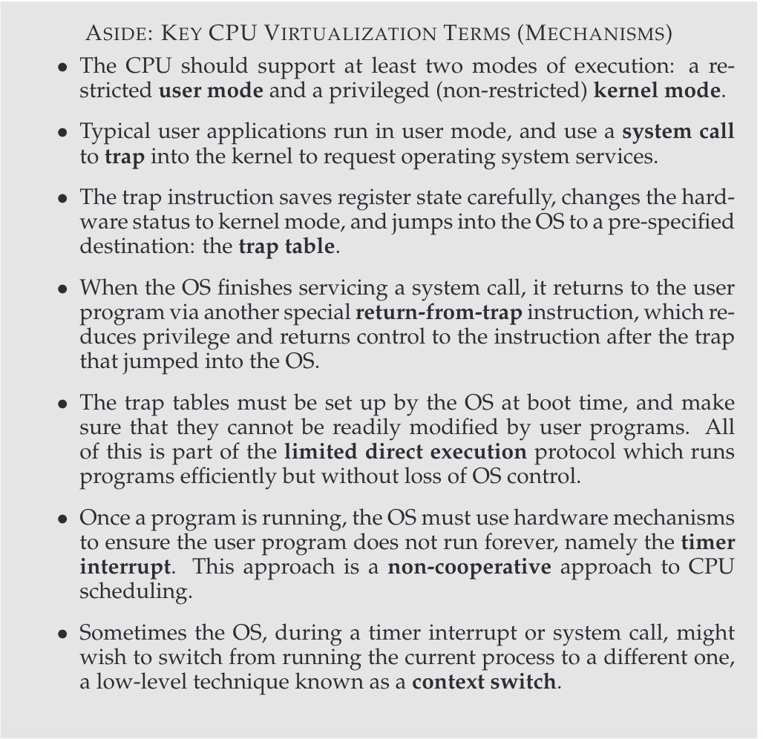

**Process State**

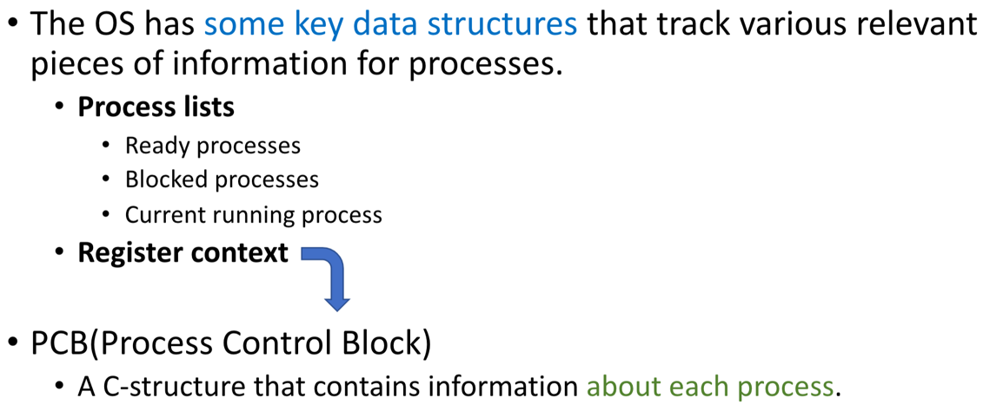

**Suspend Process**

-**Swapping**: involves moving part of all of a process from main memory to disk

-when none of the processes in main memory are in the Ready state, the OS

swaps one of the blocked processes out on to disk and into a suspend queue; makes

more memory available

CPU Scheduling

-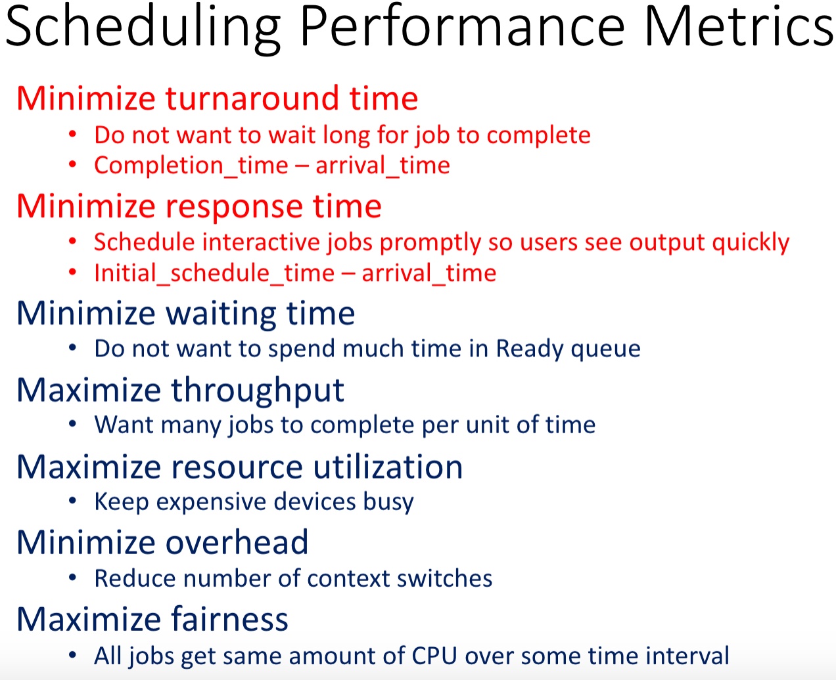

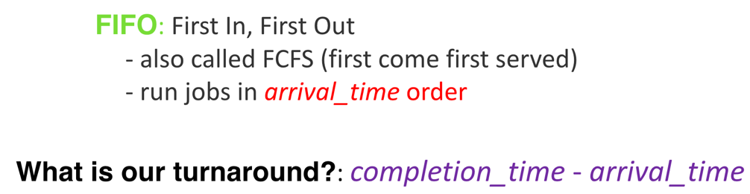

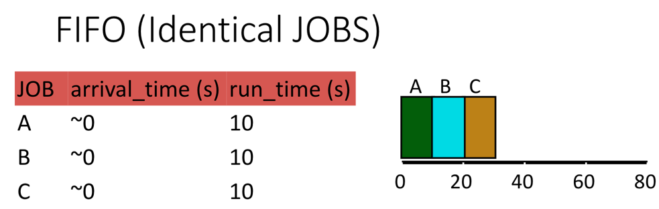

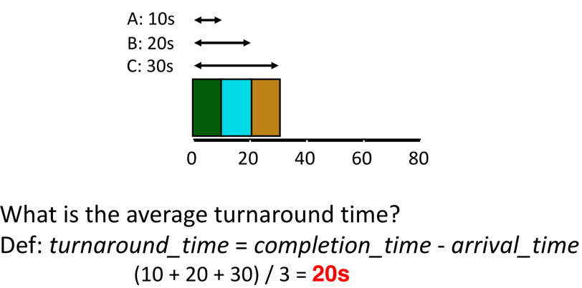

Problem FIFO: turnaround is high

-Turnaround time can suffer when short jobs must wait for long jobs

**SJF (Shortest Job First)**

-Choose job with smallest run_time

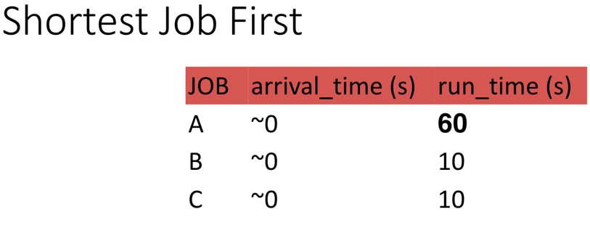

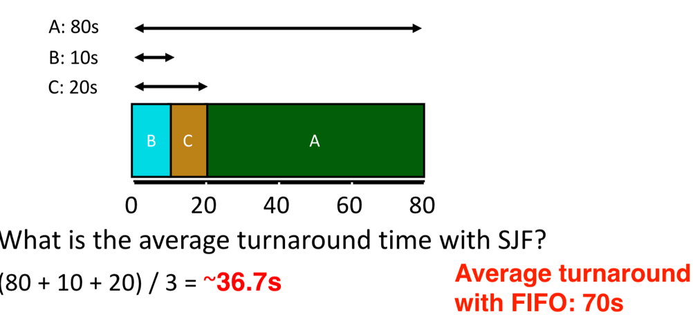

For minimizing average turnaround time (with no preemption): SJF is provably optimal

**FIFO and SJF are non-preemptive**

**STCF (Shortest Time-to-Completion First)**

-Always run job that will complete the quickest

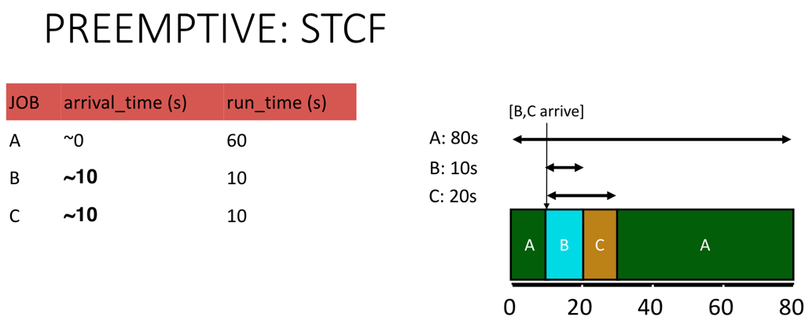

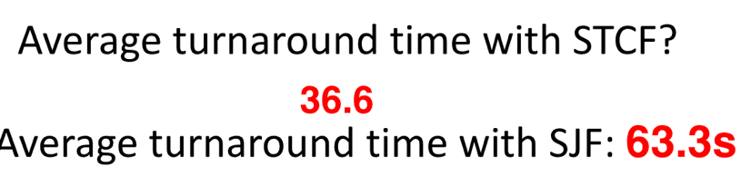



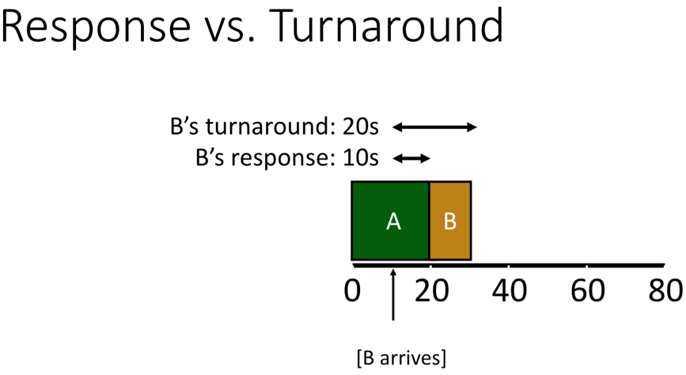

**FIFO, SJF, and STCF can have poor response time**

**Round-Robin Scheduler**

-Alternate ready processes every fixed-length time-slice

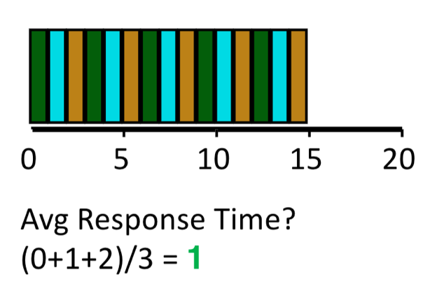

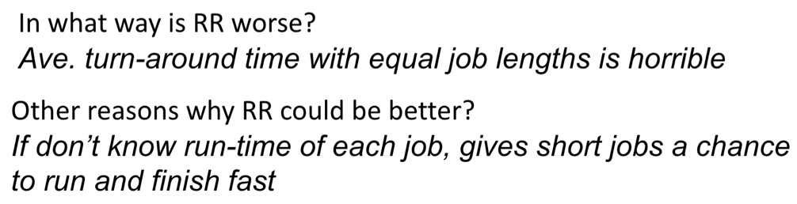

**Thread**

**-**Each **thread** has its own stack, its own **program counter**, etc., but all **threads** in a process **share** the same memory

